**“Transforming Certificate Management: Automating TLS Renewal for Smooth Kubernetes Migration”**

**Story:**

**Background:** In a recent engagement, we assisted a client in the retail sector with their migration to Kubernetes. As they expanded their e-commerce platform to meet growing customer demand, they faced significant challenges in managing TLS (Transport Layer Security) certificates, which are essential for securing communications between their services.

**Challenges:**

1. **Manual Certificate Management:** The client's existing system for managing TLS certificates involved a lot of manual processes. This created risks of human error, such as expired certificates leading to service outages. For example, imagine a scenario where a payment gateway certificate expires, causing disruptions during peak shopping hours—this could lead to lost sales and damage to the brand’s reputation.
2. **Complex Infrastructure:** Migrating to Kubernetes added layers of complexity. Without a robust solution for managing secure communications, the client risked compromising the security of their applications. Think of it as trying to navigate a busy highway without proper signs and signals—it can lead to confusion and accidents.
3. **Knowledge Gaps:** The engineering team lacked experience with automated certificate management and best practices for implementing HTTPS (Hypertext Transfer Protocol Secure) in a cloud environment. For instance, they might have known how to generate certificates manually but were unaware of how to automate renewals, leading to last-minute scrambles before certificate expirations.

**Solutions Implemented:** To address these challenges, we implemented a comprehensive solution that included automation and training:

1. **Automated TLS Certificate Management:** We introduced **Cert-Manager**, a Kubernetes add-on that automates the management of TLS certificates. This tool simplified the processes of issuing, renewing, and revoking certificates. For example, consider a situation where the client needed to roll out a new feature requiring secure communication. With Cert-Manager, they could automatically obtain and renew certificates without manual intervention, reducing downtime and ensuring secure transactions.
2. **Training and Knowledge Transfer:** After implementing the automation, we conducted training sessions for the client’s engineering team. The training focused on key concepts, including:

* **How HTTPS Works:** We explained the basics of encryption, the TLS/SSL handshake process, and how secure connections protect sensitive data. For example, we likened it to sending a sealed envelope through a postal service—only the intended recipient can open it.
* **The Role of Certificate Authorities (CAs):** We discussed how CAs verify the identities of entities online, establishing trust. We used the analogy of a government issuing ID cards to validate a person’s identity.
* **Self-Signed Certificates:** We covered scenarios where self-signed certificates might be appropriate, such as internal testing environments, while highlighting their limitations in production settings.
* **Creating an Internal CA:** We guided the team on setting up an internal CA for managing certificates for their internal services, allowing them to issue and manage their own certificates.
* **Automating Certificate Management in Kubernetes:** We demonstrated how to leverage Cert-Manager for seamless automation, ensuring they could manage certificates confidently.

1. **Security Best Practices:** We shared industry best practices for managing certificates within Kubernetes. This included guidance on key rotation, monitoring certificate expiration dates, and maintaining a secure environment.

**Outcome:** By the end of this engagement, the client’s engineering team was equipped with the knowledge and tools needed to manage TLS certificates independently. They could confidently maintain a secure and scalable production environment, mitigating risks associated with manual certificate management.

For instance, after our training, when they launched a new marketing campaign requiring secure user data transactions, they efficiently issued new certificates through Cert-Manager, ensuring a smooth rollout without service disruptions. The transition not only enhanced their security posture but also built their team's confidence in managing complex cloud environments.

**HTTPS:**

**Introduction:**

During our recent Kubernetes migration project for a retail client, we tackled several challenges related to securing their web applications. One of the main issues was managing TLS (Transport Layer Security) certificates, which previously involved cumbersome manual processes. Automating certificate management not only streamlined their operations but also ensured a secure transition to production.

**What is HTTPS?**

HTTPS (Hypertext Transfer Protocol Secure) is an extension of HTTP, which is the protocol used for transmitting data over the web. HTTPS encrypts the data exchanged between a user’s browser and the web server, ensuring that sensitive information remains private and secure. This is particularly important for online transactions, login credentials, and any data exchanges that need to remain confidential.

**How HTTPS Works:**

Before diving into how HTTPS functions, it’s essential to understand two key principles of cryptography that underpin secure communication.

**HTTPS Workflow:**

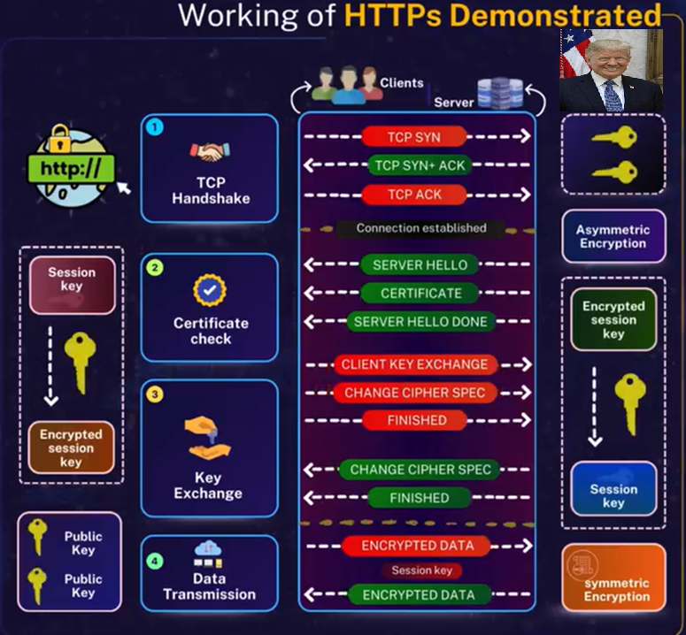

1. **Public and Private Key Pair:**
   * Any message encrypted with a public key can only be decrypted using the corresponding private key. For example, if a message is encrypted using a public key, only the owner of the private key can decrypt and read that message. This ensures confidentiality.
2. **Digital Signatures:**
   * Anyone with access to the public key can verify that a digital signature was created by the holder of the corresponding private key. This ensures authenticity and integrity, confirming that the message indeed comes from the claimed sender.

**Simple Analogy:**

Imagine a **lock and key** scenario:

* **Lock (Public Key):** The lock represents the public key, which anyone can use.
* **Key (Private Key):** Only the owner (let's say Trump) has the corresponding key to unlock it.

**When someone wants to send a secure message:**

* They can use Trump’s lock to secure a message inside a box and send it to him.
* Once it arrives, only Trump can unlock the box using his key to access the message. This illustrates how public keys encrypt messages while private keys decrypt them, ensuring that only the intended recipient can read the message.

**Detailed Explanation of HTTPS Workflow**

1. **Client Request:**
   * A user enters a URL starting with “https://” in their browser, which triggers an HTTP request to the web server.
   * For example, when a customer visits an online store, their browser sends a request to the store’s server.
2. **Server Response:**
   * The server responds by sending its **digital certificate**, which contains the public key and information about the server's identity, such as the domain name.
   * The server's certificate is signed by a trusted Certificate Authority (CA), providing assurance of the server's legitimacy.
3. **Certificate Validation:**
   * The browser checks the digital certificate against trusted CAs to verify its authenticity. If valid, it confirms that the server is indeed the one it claims to be.
   * For example, when a customer sees a padlock icon in their browser, it indicates that the site is secure and the certificate is valid.
4. **TLS Handshake:**
   * **Key Exchange:** The browser and server perform a **TLS handshake** to securely exchange a symmetric session key. The public key encrypts this session key, ensuring only the server can decrypt it with its private key.
   * This session key is used for encrypting all further communication between the browser and server.
5. **Data Encryption:**
   * Once the session key is established, any data exchanged (like credit card information during a purchase) is encrypted. This means even if someone intercepts the data, they cannot read it without the session key.
   * For example, during an online transaction, the customer’s payment details are encrypted, making it secure from potential eavesdroppers.
6. **Session Termination:**
   * At the end of the session, the session key is discarded, ensuring that even if an attacker captures data after the session ends, it cannot be decrypted without the session key.

In our Kubernetes migration project, we implemented automated TLS certificate management using **Cert-Manager** to streamline this process for our client. For instance, when the client launched a new feature requiring secure user transactions, they needed to ensure all data exchanged during the transactions was protected.

* **Before Automation:** The team manually generated certificates, which led to occasional downtime due to expired certificates. For example, during a promotional sale, an expired certificate could have prevented users from accessing the site securely, resulting in lost sales.
* **After Automation:** With Cert-Manager in place, the client could automatically issue and renew TLS certificates. This not only reduced the risk of human error but also provided peace of mind, knowing that their secure communications were always up to date.

**Let’s have a simple example:**

* Think of a lock and key. The lock represents Trump’s public key, which anyone can see and use. However, only Trump has the key to open it. Trump can give his lock (in an open state) to someone else, allowing them to use it to secure something inside. They can place their item in the locked box, lock it, and send it to Trump’s address. Once it arrives, only Trump can use his key to unlock the box and access the contents inside.

**How to Create a Secure Website**

Creating a secure website involves several key steps, which we guided our client through during the Kubernetes migration project:

1. **Obtain a Domain Name:** Choose a unique domain name that represents your brand and register it with a domain registrar.
2. **Choose a Hosting Provider:** Select a reliable hosting provider that supports HTTPS and provides the necessary security features.
3. **Install SSL/TLS Certificate:**
   * Use **Let’s Encrypt** for free certificates or purchase a certificate from a trusted CA. In our project, we automated this process with Cert-Manager, ensuring certificates were renewed automatically.
4. **Configure Web Server:**
   * Set up your web server (like Nginx or Apache) to support HTTPS. Redirect HTTP traffic to HTTPS to ensure all communications are secure.
   * Example: In our client’s case, we configured Nginx to listen on port 443 (the default port for HTTPS) and serve traffic securely.
5. **Implement Security Best Practices:**
   * **Use Strong Encryption:** Configure your web server to use strong encryption protocols (like TLS 1.2 or higher).
   * **Regularly Update Software:** Keep your web server and applications up to date to protect against vulnerabilities.
   * **Conduct Security Audits:** Regularly test your website for vulnerabilities and fix any issues.
6. **Monitor and Maintain:**
   * Use monitoring tools to check for expired certificates and ensure SSL configurations remain secure.